Ordinance #2020-1236
Ordinance of the Borough of Manville, New Jersey, to Amend Ordinance #2020-1230 Authorizing the Purchase of Block 180, Lot 31-32, Located on Manville Avenue, Manville, NJ in order to include Block 180 Lots 27-28

Statement of Purpose
The purpose of this Ordinance is to amend Ordinance #2020-1230 to include
Block 180 Lot 27-28, commonly known as 813 Manville Ave. that was mistakenly omitted.

WHEREAS, Ordinance 2020-1230 was adopted on March 09, 2020, and
WHEREAS, Ordinance 2020-1230 authorized the purchase of Block 180 lot 31-32 for the purchase price of $1.00, and
WHEREAS, said Ordinance 2020-1230 mistakenly omitted Block 180 Lots 27-28, commonly known as 813 Manville Avenue,
NOW, THEREFORE, BE IT ORDAINED by the Mayor and Council of the Borough of Manville in the County of Somerset, New Jersey “(the Borough”) that:
- Block 180 Lots 27-28 (813 Manville Avenue) be included in the Statement of Purpose for Ordinance 2020-1230,
- That all applicable conditions and pre-requisites to purchase as delineated in Ordinance 2020-1230 Sections 1.-6 are hereby applied to this ordinance and the purchase of Block 180 Lots 27-28
- The cost of acquisition for Block 180 Lots 27-28 is included in the original $1.00 (one dollar) acquisition cost as specified in Ordinance 2020-1230,
- This Ordinance shall be effective immediately upon final adoption, approval and publication in accordance with law.

Borough of Manville,
Richard M. Onderko, Mayor

ORDINANCE #2020-1236
FIRST READING:

ROLL CALL
Introduced | Seconded | Council | Yes | No | Abstain | Absent
 |  | MAGNANI
 |  | LUKAC
 |  | MAEDER
 |  | PETROCK
 |  | SZABO
 |  | ZAMORSKI
 |  | MAYOR ONDERKO

INTRODUCED this 26th day of May , 2020

Attest: 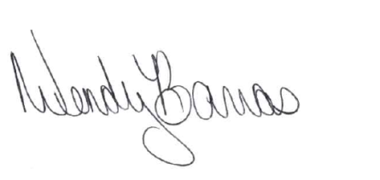
Wendy Barras, Borough Clerk

SECOND READING:

ROLL CALL
Introduced | Seconded | Council | Yes | No | Abstain | Absent
 |  | MAGNANI
 |  | LUKAC
 |  | MAEDER
 |  | PETROCK
 |  | SZABO
 |  | ZAMORSKI
 |  | MAYOR ONDERKO

[ADOPTED] [DEFEATED] this 8th day of June, 2020

Attest:
Wendy Barras, Borough Clerk

